EXP NO : 4
Aim
Perform image dilation using OpenCV morphological transformation technique.
Algorithm
Import OpenCV, NumPy and Matplotlib required libraries.
- Read input image from specified file location.
- Create five-by-five kernel using NumPy ones function.
- Apply dilation using kernel for single iteration.
- Convert dilated image from BGR to RGB.
- Display dilated image using Matplotlib visualization function.
Code
import cv2
import matplotlib.pyplot as plt
import numpy as np

img = cv2.imread("/content/Picture3.jpg")

kernel = np.ones((5,5), np.uint8)

dilate = cv2.dilate(img, kernel, iterations=1)

plt.imshow(cv2.cvtColor(dilate, cv2.COLOR_BGR2RGB))
plt.show()

Output:
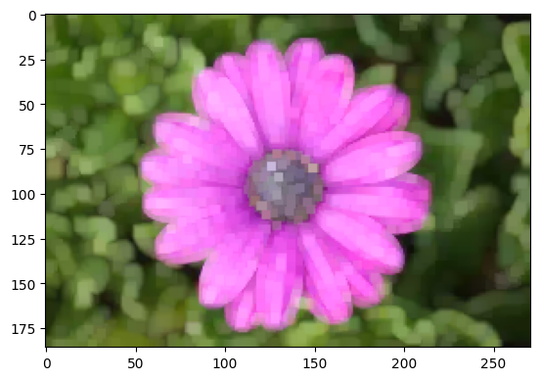
Result
The input image was successfully dilated using a 5×5 kernel, and the dilated image was displayed successfully.

